What Is Sound?

Before we start, why are we learning about sound - we're programmers?
Sound has always played a part in computer games – although not always to the extent that it does today.
Think back to the very early computer games – if, indeed you are able – and think about the sort of sounds that were used. Games like Pong and Space Invaders used a succession of beeps and pings to create sound effects. The sounds themselves were very crude, but it is significant that they are there, since it is an early attempt to use sound to provide a form of audio feedback to back up the important actions onscreen.

Sound Clip 1.1 – The sounds of a typical game of Pong.
The sounds of the monophonic game were with us until the very early eighties when sound consoles and home computers began to be built with dedicated sound hardware. For example, the Mattell Intellivision console which was released in 1979 contained what was, at the time, a very advanced audio system – a 3 channel programmable sound chip. This allowed for more complex sounds to be created, and although the explosions and gunshots couldn’t be mistaken for the real thing, they were at least a step in the right direction.
Things continued along the same lines for a few more years – even the Atari ST contained a 3-channel soundchip, with frequency range 30Hz to 125 kHz. It wasn’t until the launch of Commodore's Amiga 500 in 1986, that any significant steps forward in audio took place. The Amiga was designed to be able to play 4 channels of 8-bit sampled sound, as well as having the MOS6581 (aka SID) 3 channel sound chip from its predecessor the Commodore C64.
Although many systems before this could be coaxed by keen programmers into playing digital recordings of sounds (samples) – some examples include Ghostbusters for the Speccie and C64, and Xenon and Starglider for the ST – none had been designed specifically with this purpose in mind, and the results achieved were usually poor.

Sound Clip 1.2 – A C64 Sampled Sound (4K) and an Amiga Sampled Sound (15K).
This opened the way for much more realistic audio environments in games. Games Designers could now use the same arsenal of sound effects that had been available to the film industry for years. The only extra limitations imposed on them were those of limited RAM and channel resources.
Sampled sound has been so successful as a method of audio reproduction that since the introduction of the Amiga 500 it has remained the standard method used in all home systems. The current most popular consoles, Sony's Playstation and Playstation 2, Nintendo's N64, and Sega’s Dreamcast all rely on sample playback for generating audio.

In the last 13 years technological advancements have merely improved the quality of the sound playback (16 bit instead of 8 bit, and higher sample rates) and the number of sound channels that can be played back simultaneously (from 4 up to 128+ at the latest count). Other advances have been made by adding Digital Signal Processors to add effects such as reverb and to add environmental effects such as those provided by Creative Labs (EAX) and Aureal (A3D), but the fundamental technology used has not changed since 1986.

OK, so sound is in games alright, but I can't do it - I'm not musical
What a lame excuse.
This is not a music course, although we do touch on music later on. What this module is really all about is equipping you with the skills to:
- make informed choices about music and sound effects in games
- develop enough of a technical vocabulary and an understanding of what is and isn't possible to be able to talk to enter into meaningful dialogue with the sound guy
- be able to take sound files and incorporate them into a game using, for example, Direct X.
So there we are. I'm not expecting you all to become kick-ass sound engineers. That would be silly. What I do want you to get out of this module is a greater appreciation for how sound is used and implemented within a gaming environment.
So onwards with the question that should now be playing on your mind:

So what exactly is sound then?
Well, I consulted my dictionary and managed to come up with the following definition:
Sound is a form of energy which propagates through a host medium in the form of longitudinal waves.
Yikes.
Let’s look at the sentence piece-by-piece.
We begin by saying that Sound is a form of energy. This shouldn’t cause too much mental anguish, since most people feel quite comfortable with the notion of energy as a ‘source of power’, such as light or heat. Sound may be thought of in the same way. Indeed, sound is frequently present when one form of energy is converted to another. For example, when electrical energy is converted into the light of a lightbulb, or the heat of an electric fire, a buzzing sound can often be heard because the conversion process is not completely efficient and some energy ‘leaks out’ as sound.
When we speak of the sound propagating through a host medium, we mean that the sound requires something physical to move through. This is quite different from other types of energy such as light and heat which can travel through a complete vacuum – a region of space in which there exists nothing at all. This has to be the case or else how could energy from the Sun reach us through the vacuum of the Solar System? Contrary to what some movies might have you believe, however, because sound needs something to travel through, outer space is really a pretty quiet place!
Finally, the sound travels as longitudinal waves. Again, you should be quite familiar with the concept of energy travelling as waves – the waves that travel along the surface of the world’s seas are just one example. However, the longitudinal motion of sound waves is subtly different from the transverse motion of water waves.
In the more familiar transverse waves, the displacement of the medium is at right angles to the direction in which the waves are travelling (see Figure 1.1). Thus, since the energy travels along the surface of the water, the water itself moves up-and-down. This can be seen by watching a boat bobbing on the waves – the boat bobs up-and-down with the motion of the waves, but always stays in the same spot.
This is an important point to note, since the vibrations that produce sound are not the result of an entire volume moving back and forth at once. If that were the case, the entire atmosphere would need to shift for any sound to be made at all! Instead, the vibrations occur among the individual molecules of the substance, and the vibrations move through the substance in sound waves. As sound waves travel through the material, each molecule hits another and returns to its original position. The result is that regions of the medium become alternately more dense, when they are called condensations, and less dense, when they are called rarefactions.
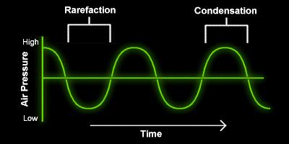
Figure 1.1 – In transverse waves, the displacement of the medium is at right angles to the direction of wavefront travel.
In longitudinal waves, however, the displacement of the medium is in the same direction as that in which the waves are travelling (see Figure 1.2). This results in a bunching together and spreading out of the material, and is probably best visualised by considering the motion of a ‘slinky’ spring given a shove along its length.
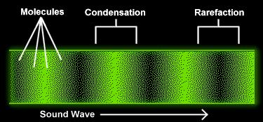
Figure 1.2 – In longitudinal waves, the displacement of the medium is in the direction of wavefront travel.
To summarise, then, sound is essentially just vibrating stuff in which the stuff wobbles in-and-out rather than up-and-down.

Visualisation of sound
There is a slight problem with longitudinal waves in that it is very difficult to depict them graphically. However, there is a neat solution to this.
In Figure 1.2 above, as we move from left-to-right along the diagram we are really moving from left-to-right through the material, passing densely and sparsely packed regions as we do so.
If, instead, we stand at a fixed point in space and allow the sound wave to travel past us, we can measure the density of the material as time progresses. If we then plot the results we arrive at something like Figure 1.1. Here, in moving from left-to-right along the diagram, we are moving through time. The base line halfway up the diagram represents the normal density of the material, with points above this line representing an increase in density and those below it representing a decrease.
From now on, we will always represent sound waves in the form of transverse waves, because they are easier to draw and to make sense of than the longitudinal represenation.

The important bits
There are four main parts to a sound wave: wavelength, period, amplitude, and frequency. In this section, we will discuss each one of these parts. Also, we will talk about pitch and its relation to the frequency of a sound wave.
The wavelength is the horizontal distance between any two successive equivalent points on the wave.
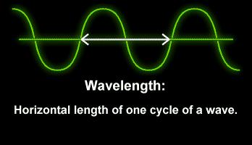
Figure 1.3 – Wavelength.
The period of a wave is the time required for one complete cycle of the wave to pass by a point. So, the period is the amount of time it takes for a wave to travel a distance of one wavelength.
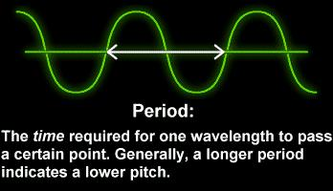

Figure 1.4 – Period.
Every cycle of sound has one condensation and one rarefaction. The frequency of a sound wave is measured in hertz (Hz), and this indicates the number of cycles per second that pass a given location. For example, if a speaker's larynx is vibrating back and forth at a frequency of 900 Hz, then 900 condensations are generated every second, each followed by a rarefaction, forming a sound wave whose frequency is 900 Hz.
It is important to note that the period and the frequency of a wave are very closely linked with one another. Recall that the period of a wave is the time taken for one complete cycle to pass a particular point, whilst the frequency is the number of cycles that pass a particular point in one second. Clearly, then, if we have a period of x seconds (i.e. one wave every x seconds), this will result in a frequency of ¹/_{x} Hz (i.e. ¹/_{x} waves every second).
How the brain interprets the frequency of an emitted sound is called the pitch of that sound. In general, the faster the vibrations the emitted sound makes (or the higher the frequency), the higher the pitch. Note that pitch is not the same as frequency, although the two go hand in hand. The frequency is a physical quantity – a measure of the number of cycles of a particular wave that pass a particular point in a second. The pitch, on the other hand, is the word we use to describe the way in which the brain interprets that information.
Humans can normally hear sound frequencies between about 20 and 20,000 Hz (20kHz). When the frequency of a sound wave lies above 20 kHz, it is called an ultrasonic wave. While we cannot hear ultrasonic waves, we apply them in various technologies such as sonar systems, sonograms, surgical tools, and cleaning sytems. Some animals – such as bats and some marine mammals – also use ultrasonic waves in a specialized technique called echolocation that alows them to pinpoint objects and other animals, even in the dark.
The amplitude of a sound is represented by the height of the wave. Generally speaking, loud sounds result in waves with large amplitudes. The unit of measurement of ‘loudness’ is the decibel, notated dB.
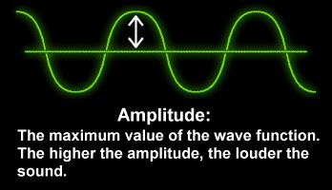

Figure 1.5 – Amplitude.
The decibel scale is named after Alexander Graham Bell, who, when he wasn’t inventing the telephone, discovered that in order to produce a sound that is twice as loud as another sound, the intensity, that is, the sound energy per unit area per second that hits the eardrum needs to be increased tenfold. This results in a logarithmic scale – one in which the scale increases multiplicatively, rather than additively.
Note that the value of 0 dB does not mean ‘no sound present’. Rather, it is a reference point that corresponds to the lowest level sound that the average human with normal hearing can hear. It is possible to hear sounds at this very low level only under exceptional circumstances, such as being inside a sound booth that reduces all of the extraneous sounds.
Rub your finger back and forth very lightly on your ear. You will hear sounds around 30 to 50 dB SPL or so depending how hard you are pressing against the skin and where on your ear you are rubbing. If you continue rubbing your finger back and forth with the same pressure, but move it onto your cheek toward your nose, the sound will decrease and you will reach a point on your cheek where you are just able to hear it.
Moving your finger all the way to your nose should produce an inaudible sound and moving your finger back toward your ear should make the soft sound audible again. The sound generated at the point on your cheek where it is just audible is very close to 0 dB.
How can this work without being in a sound booth? It turns out that our ears are able hear at 0 dB only for a very limited range of frequencies: those around 1500 to 4000 Hz. Our hearing is much less sensitive for lower and higher frequencies, meaning that such sounds must be considerably louder than 0 dB for us to hear them. Ambient noise tends to be concentrated much more toward the lower end of the frequency scale, where our hearing sensitivity is not as good. Rubbing your finger on the skin produces sounds all across the frequency spectrum. In the experiment above, the lower frequency sounds are masked by the lower frequency ambient noise and we hear only the higher frequency portion of the sound, right where the hearing sensitivity is the greatest and right where the ambient noise is least obtrusive. Therefore the sound should be close to 0 dB.
Some examples of loudness are presented below.
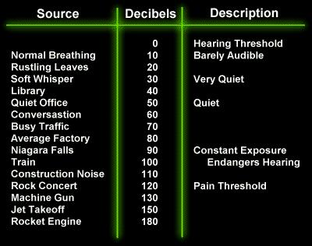
Figure 1.6 – The decibel scale.
Finally, the timbre of a sound is its tonal quality. This is what characterises particular types of sound, such as wind sounds, keyboard sounds, noise, and so on. The timbre of a sound is very closely related to the shape of the associated waveform, and although it's difficult to correlate exactly between waveshape and tone quality, generally speaking, the more complex the waveshape, the richer the sound.

© Kenny McAlpine, 2002

